DEEPER LIFE HIGH SCHOOL
SS1 SECOND TERM EXAMINATION, 2014/2015
MARKING GUIDE: GEOGRAPHY
SECTION A (Objective Test: ½ mark each = 30 marks)

1. A | 11. A | 21. E | 31. D | 41. A | 51. D
2. B | 12. B | 22. E | 32. B | 42. B | 52. C
3. C | 13. B | 23. B | 33. D | 43. C | 53. B
4. B | 14. D | 24. A | 34. D | 44. A | 54. D
5. C | 15. A | 25. B | 35. C | 45. B | 55. B
6. C | 16. E | 26. E | 36. A | 46. C | 56. B
7. C | 17. A | 27. D | 37. C | 47. D | 57. D
8. E | 18. B | 28. C | 38. B | 48. B | 58. B
9. D | 19. B | 29. B | 39. E | 49. C | 59. C
10. E | 20.E | 30. A | 40. A | 50. D | 60. D
SECTION B (ESSAY)
Answer any three questions from this section.
Question: 1a. Name three types of mountains with one example each
Answer: 1a. Three types of mountain are
- Fold mountains e.g Himalayas, Rockies, Andes, Alps and Atlas mountains.
- Block mountains e.g Huns-ruck mountain, Vosges mountain and the block forest of the Rhine land.
- Volcanic mountains e.g Mountain fuji (Japan), Mt mayon (Philipines),Mts Kilimanjaro, Kenya, Elgon, Ruwenzori and Cameroun.
- Residual mountains e.g Mt Monadnock (USA), Highlands of Scotland, Highland of Scandinavia, Deccan plateau, Idanre Hills, Ado Rock in Western Nigeria and the Dala and Dutsi in Kano City.
(Any three with correct example at 1mark each= 3marks)
Question: 1b. Describe the process of formation of any one of the types of mountains.
Answer: 1b Process of formation of type of mountains are
- Fold Mountains
- They are formed by large scale horizontal earth movement as a result of stress and compression forces which cause-expansion or contraction of some parts of the earth.
- The compression forces produce wrinkling or folding of the crust of the earth.
- The up folds of the wrinkles are anticlines while the down folds are called syncline.
- A fold may be simple, but where the compressional forces are complex, it results in asymmetrical folding. When pushed further, it forms an over-fold; an overfold later forms a recumbent fold. Where there are cracks or faults in extreme folding. It forms over thrust fold.
- Examples include Himalayas, Rockies, Andes, Alps and Atlas mountains.
- Block Mountains
- They are caused by faulting accompanied by tension and compressional forces.
- If the block enclosed by the faults remains as it is while the land on either sides of the block subsides, the upstanding block becomes the horst or block mountain.
- Examples include Huns-ruck mountain, Vosges mountain and the block forest of the Rhine land.
- Volcanic mountains
- They are formed from volcanoes.
- They are built up from molten rock/magma ejected through fissures or vents in the earth’s crusts.
- The molten materials include molten lava, volcanic bombs, cinders, ash, dust and liquid mud.
- They fall around the vent in successive cone layers.
- Another name for volcanic mountain is mountains of accumulation.
- Examples include Mountain Fuji (Japan), Mt mayon (Philipines),Mts Kilimanjaro, Kenya, Elgon, Ruwenzori and Cameroun.
- Residual Mountains
- They evolved from denudations.
- They are formed from already existing mountain which are lowered or reduced by agents of denudation such as running water, ice and wind.
- The resistant areas may remain and this forms Residual Mountain.
- Residual Mountains are referred to as Mountain of denudation.
- Examples include Mt Monadnock (USA), Highlands of Scotland, Highland of Scandinavia, Deccan plateau, Idanre Hills, Ado Rock in Western Nigeria and the Dala and Dutsi in Kano City.
(Any three points well explained at 1mark each =3marks)
Question: 1c. In what four ways are mountains of great importance to man?
Answer: 1c. Mountains are of great important to man in the following ways:
- They serve as source of rivers e.g. River Niger from the Guinea highlands.
- They modify the climate of the surrounding area for human settlement e.g. Jos plateau, Mts Kenya, Elgon, Kilimanjaro, etc.
- They serve as tourist attraction e.g. Olumo rock, Idanre hills.
- Sources of mineral e.g. Tin and Columbite from Jos plateau, coal from Udi hills, gold from Ilesha.
- Mountains encourage relief rain formation.
- They may serve as natural boundaries e .g Cameroun Mountain which separates Nigeria and Cameroun.
- They may serve as defense against external invaders.
- For trancehumans e.g. Switzerland, and Australia
(Any four points at 1mark each=4marks)

Question: 2a. Describe three types of environment
Answer: 2a. Three types of environment are:
- PHYSICAL ENVIRONMENT: This can be defined as all the natural physical constituents that can be felt, seen and handled. This includes the relief, water bodies, climate and vegetation.
- SOCIAL ENVIRONMENT: Social environment can be defined as man’s interaction with his physical and cultural environment; that is man’s interaction with both natural and man-made environment as well as his interaction with his fellow man.
- CULTURAL ENVIRONMENT: Cultural environment can be defined as the man made environment; in other words it is the environment made by man for his comfort. The cultural environment of man varies from place to place, depending on the environment condition of that particular place. Examples are banks, roads, market, hospitals etc.
(Any points well explained at 2marks each=6marks)
Question: 2b Give four benefits of hydrosphere to man
Answer: 2b. Benefits of hydrosphere to man are:
- It provides water for domestic uses e.g drinking, washing, bathing, etc
- It provides water for industrial uses.
- It serves as a means of transportation.
- It provides employment opportunities for the people dwelling in the riverine areas. E.g fishing
- It is used for generating electricity.
- It is also used for irrigation purpose.
- It serves as tourist centre e.g. bar beach.
(Any four points at 1mark each=4marks)
Question: 3a. Distinguish between weather and climate
Answer: 3a Differences between weather and climate are
- Weather is the condition of lower atmosphere over a short period while climate is the average weather conditions of a place over along period at 35years.
- Weather of any place change from day to day while climate is comparatively constant over a long time.
- Weather is brief and change regularly while climate last for a very long time before it can change.
(Any point two at 1mark each=2marks)
Question: 3b. Explain four factors that affect weather and climate
Answer: 3b. Four factors that affect weather and climate are:
- Latitude: - Due to the inclination of the earth the intensity of sunshine varies from one latitude to another. The tropical latitudes are hotter than the temperate latitudes. This influences climate variables which determine the different climatic zones of the world.
- Altitude: - Places nearer the earth surface are warmer than those higher up. The rate of decrease in temperature with height is called environmental lapse rate. Higher lands experience more rainfall as highlands induce Orographic rainfall.
- Distance from the sea/Continentality: - Places closer to the sea may experience more rainfall depending however on the direction of the prevailing winds.
- Ocean Current: - Coastlands that are washed by warm currents tend to have an increased temperature while those washed by cold currents tend to have reduction of temperature.
- Cloud Cover: - Areas of more cloud cover tend to experience high humidity and consequently more rainfall more than those with less cloud cover.
- Wind: Winds blowing on-shore over warm currents bring a lot of rain, particularly if a mountainous relief obstructs the passage of the winds inland e.g. Western Britain and Norway.
- Natural vegetation: A dense and thick vegetation prevent the solar radiation from reaching the ground. As a result of this, the forest temperature is cool and lower than that of open ground. Also, as a result of transpiration that takes place, water is lost to the atmosphere and air above the vegetation is cooler.
- Soil: Light soils reflect more heat (Albedo) than dark soils. This result into differences in temperature of the soil.
- Slope and aspect: When a slope is facing the direct ray of sun, this area will have higher temperature than other part of the hill that are shielded from the sun. Steep slope experiences more rapid change in temperature than a gentle slope.
(Any four explained at 2marks each=8marks. NB: Listing= ¹/₂ mark, Explanation=1¹/₂ marks)

Question: 4a. Draw a sketch map of Nigeria and on it, mark and name: (i) One area of high population density (ii) One area of low population density (iii) One important town in each area shown.

Answer: 4a.
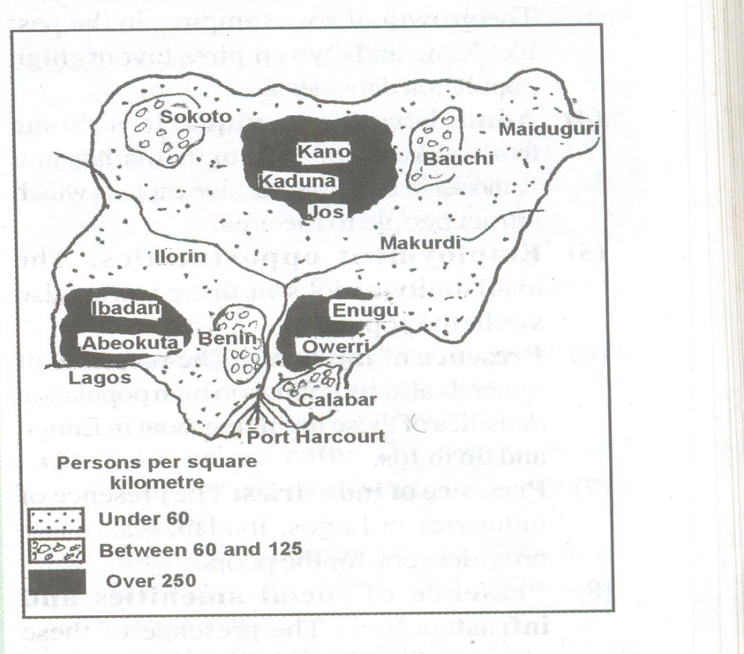
Sketched map=1mark
Location and name=1mark each=2marks
One important town in each location= 1mark each=2marks
Question: 4b. Give five reasons for any of the population density shown on your map
Answer: 4b. Reasons for any of the population density shown on the map
REASONS FOR HIGH POPULATION DENSITY
- Favourable climate.
- Fertile soil.
- Natural attachment/historical factors.
- Employment opportunities.
- Presence of minerals.
- Migration.
- Commercial activities.
- The presence of social amenities and infrastructure.
- Presence of industries.
(Any five points at 1mark each=5marks)
OR
REASONS FOR LOW POPULATION DENSITY
- Low economic activities.
- Inadequate industries.
- Inaccessibility.
- Presence of some insects.
- Slave trade/historical factors.
- Inter-tribal wars.
- Relief.
- Inadequate social amenities
(Any five points at 1mark each=5marks)

